Search for Entra ID

Select Entra ID from the List:

Select App Registration from the Left menu:

Create a new App Registration by adding a new name and click register:

Capture the Application ID (appID) and Tenant ID from the Grid:

Click the secret and generate the new secret by clicking the New Sceret option:

Capture the Secret Value(scret)

Next go to the Azure Data Lake ISM and add role of Data Contributor for the newly registered application:

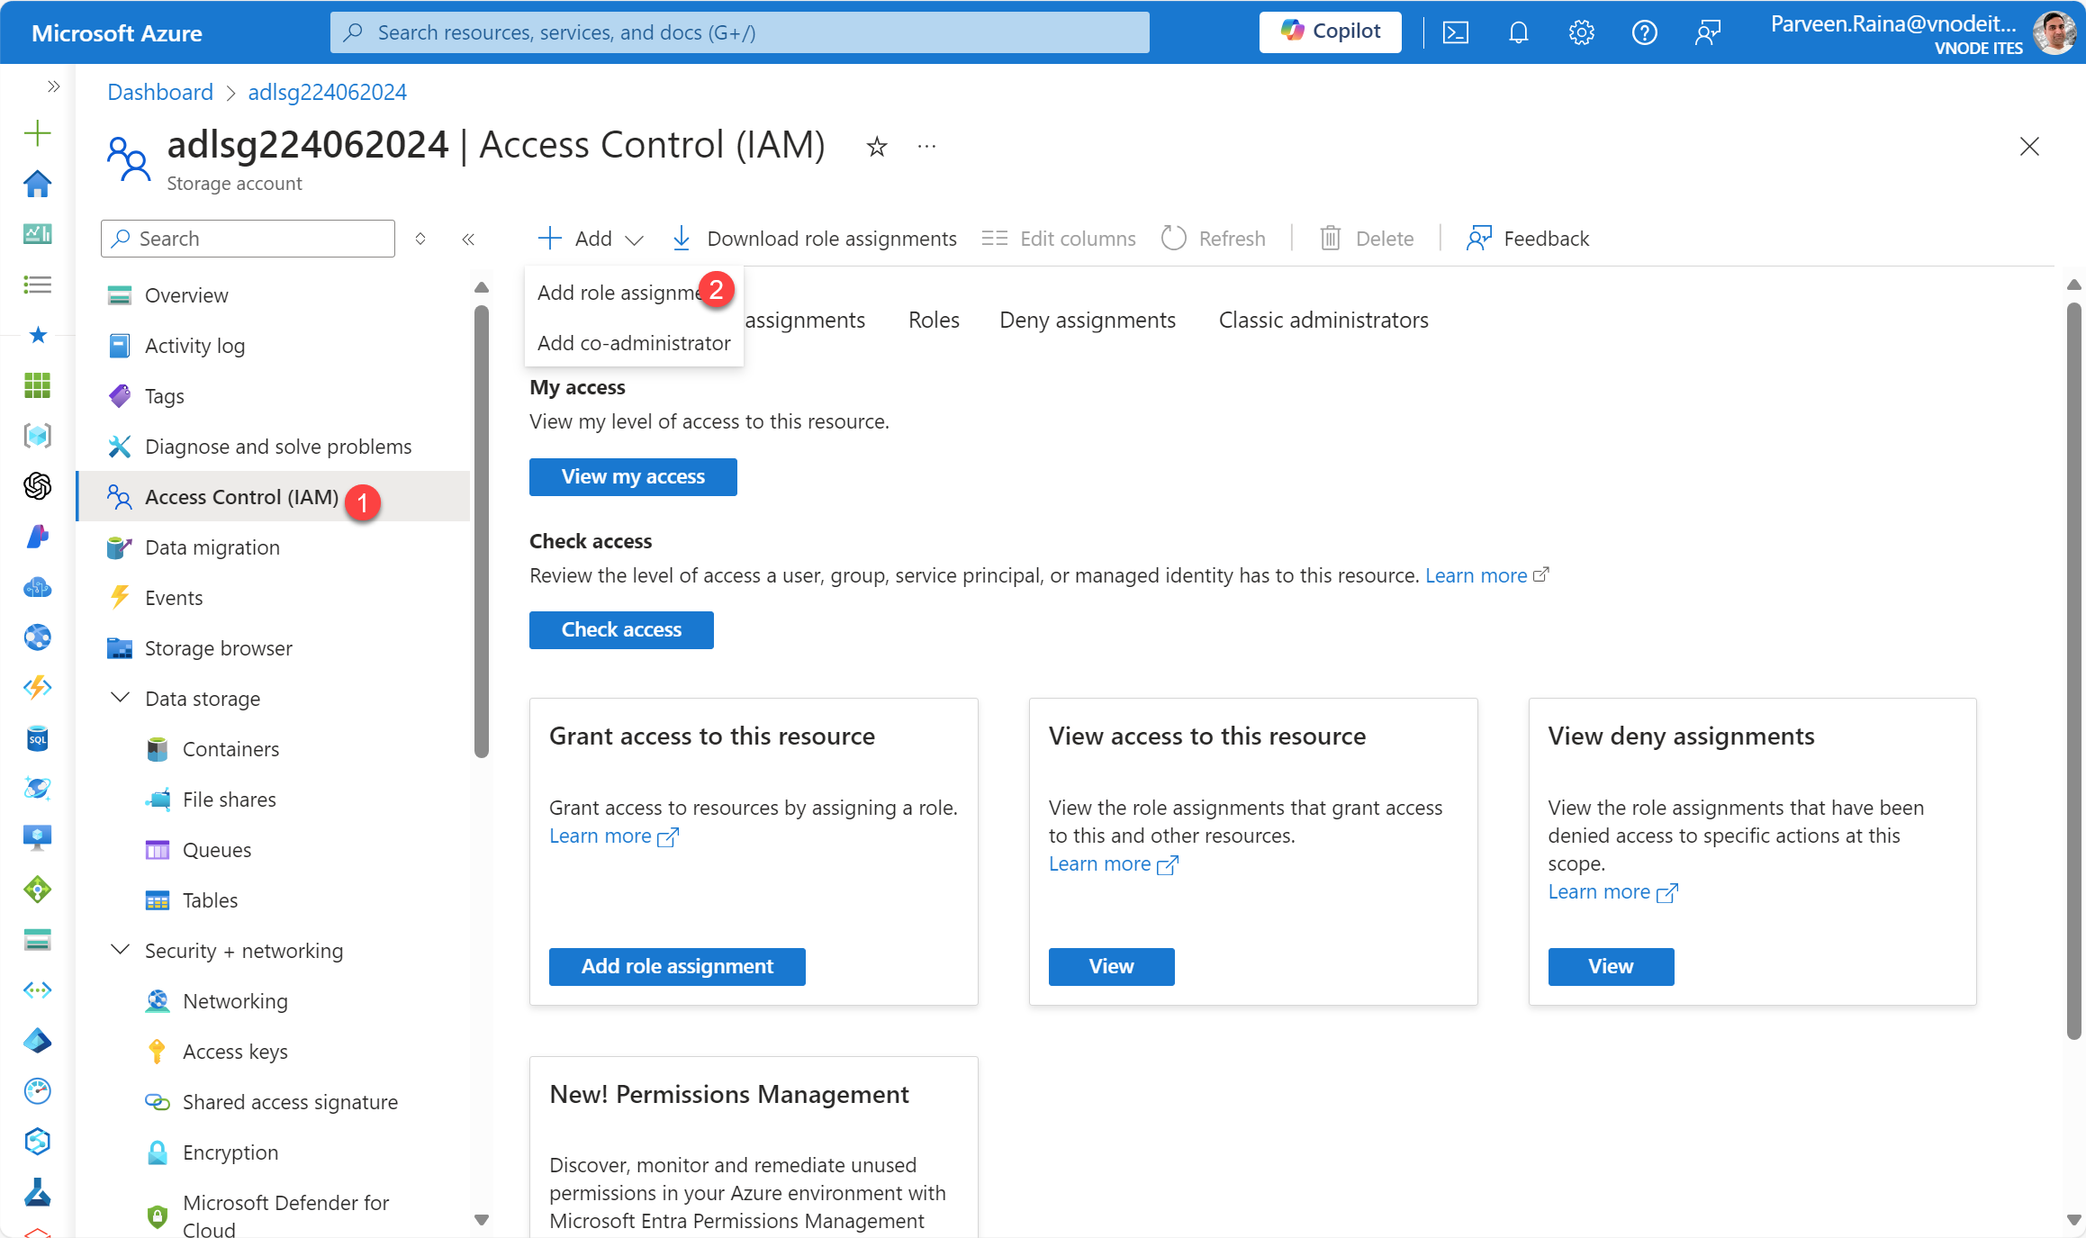

Search for the newly created databricks app:

